6A^{th} Grade: Unit 9, Lesson 5
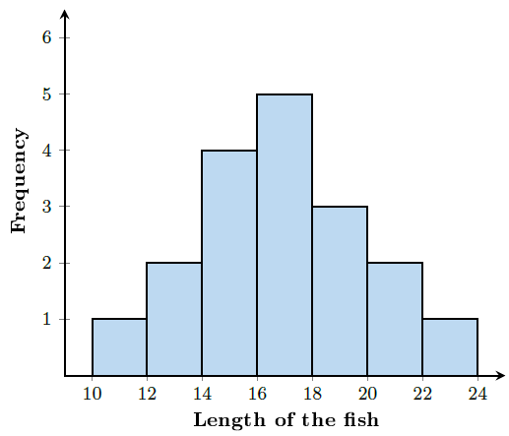
- Can the number of fish caught be determined using the histogram? Explain.

Yes, because you can add up the total from each range of length of the fish.

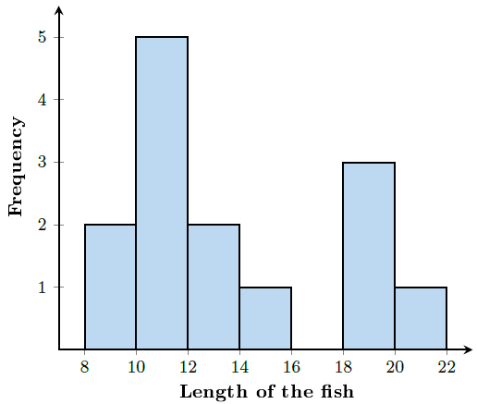
- Can the number 17 be included data set this histogram represents? Why or why not?

No, because 17 would fall in the range of 16-18, which has no data to report.

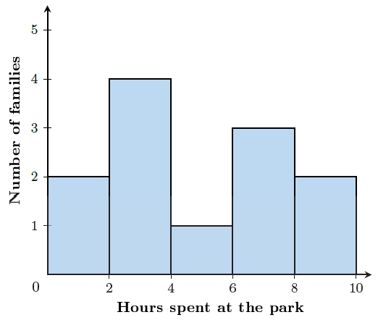
- How many families spent between 0-2 hours at the park?

2

